# Analyzing Student Performance Using the Open University Learning Analytics Dataset (OULAD)

**1. Aim of the Project**

The aim of this project is to analyze the Open University Learning Analytics Dataset (OULAD) to understand the factors that influence student performance. The analysis focuses on:  
- The impact of demographic factors such as gender, disability status, and prior education.  
- The relationship between assessment scores, engagement (measured via clicks), and final results.  
- The effect of multiple attempts and prior academic history on student success.  
  
The ultimate goal is to generate insights that can help educators improve teaching strategies, support at-risk students, and enhance overall learning outcomes.

**2. Results and Analysis**

Key Findings:  
1. Disability and Performance: Students without disabilities had a slightly higher pass rate compared to those with disabilities, suggesting potential barriers for disabled students.  
2. Assessment Score vs Final Result: Higher assessment scores strongly correlated with passing, but there were some cases where high scorers still failed due to non-completion.  
3. Gender and Performance: Performance was generally similar across genders, there isn’t major impact on the module.  
4. Highest Education Level: Students with higher prior education (e.g., degree holders) tended to perform better, especially in more advanced modules.  
5. Number of Previous Attempts: Students retaking modules had mixed results, some improved, but repeated failures were common among those with multiple prior attempts.

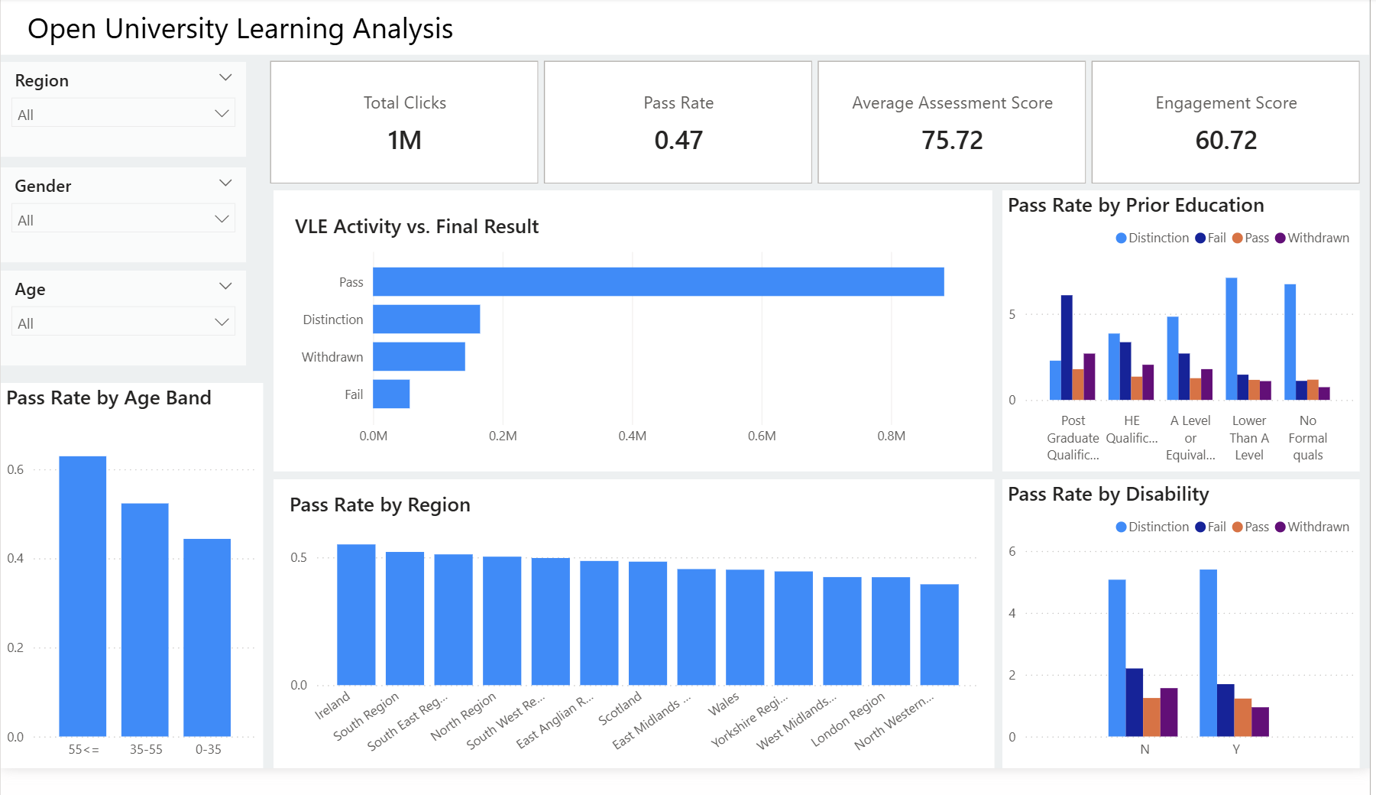

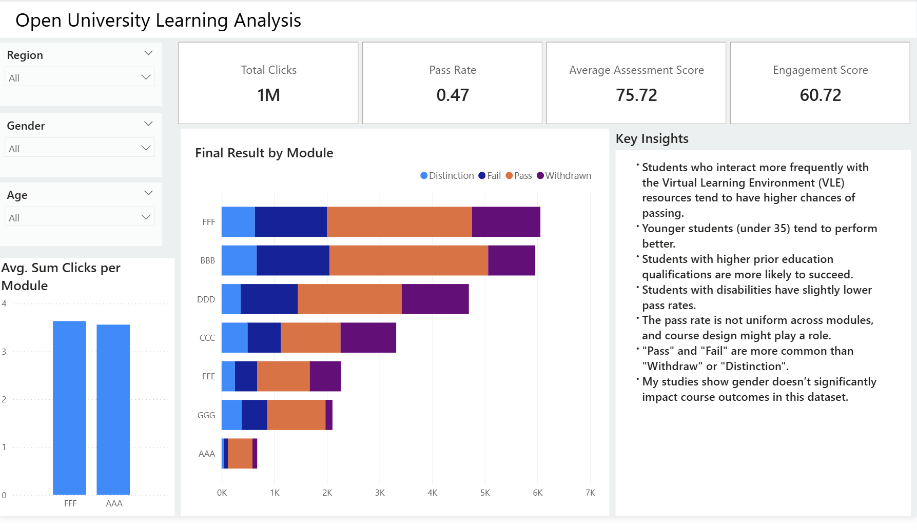

**3. Discussion**

The analysis confirms that both academic engagement and demographic factors influence student outcomes.  
- Engagement Metrics: Total clicks and assessment participation are strong indicators of success, highlighting the importance of active learning.  
- Demographics: Disability and lower prior education levels may require targeted support strategies.  
- Retention Issues: Dropout rates could be reduced by early interventions, especially for repeat students with poor historical performance.  
  
This suggests that universities should adopt data-driven student support systems, for example, using real-time dashboards to flag at-risk students based on engagement and past performance.

**4. Conclusion**

This project identifies patterns that influence student success. The findings emphasize that:   
- Continuous engagement monitoring can help predict performance.  
- Support programs should be tailored for students with disabilities and those from lower educational backgrounds.  
- Tracking assessment scores early in the semester can guide timely interventions.  
  
By applying these insights, educational institutions can enhance student retention, improve learning experiences, and boost overall academic performance.